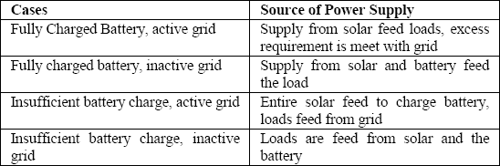

Example of condition to trigger system.

When fully charged battery, active grid

Either the energy from the PV is synchronized with the grid and supplied to the load or discrete switching can be implemented with cheap and effective operation without having to use complicated and expensive phase locked loop control and synchronization algorithm. The discretized method is prioritized and implemented in the lab. This proposed technology can also be utilized in the developed countries as well for cheap and reliable alternative to grid synchronization as it promises to not only reduce the electricity consumption from the Grid and thus the bill of electricity but also make the reliable supply to the load in the home.

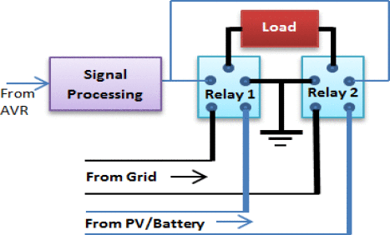

High speed switching solid state relay

16 bit AVR is used for the interface that controls all the operation within the system as all the signals flow in and out of the AVR. Special techniques have to be used to protect the microcontroller from external circuit. The internal ADC used in the microcontroller has the range of 0–5 V and gives the output current in the range of mA. As such interface circuits should be used to make a microcontroller interface to the system indirectly. It has to be also prevented from the back flow of current. Further the pull up resistor is used in the circuit for the effective operation with external interface.

=> 16 bit microcontroller.

Smart switch controller:

Unlike typical method of separate load system, the same load can be supplied with varied source with an attempt to make the system highly efficient and effective. The power loads are sampled to very small load units thus almost all the available energy from the solar source is utilized. The output signal of arduino is used for switching of load supply between Grid and Solar PV/Battery. The use of high speed switching solid state relay rated 5V DC is very effective for the purpose. The processing signal between Grid and Solar PV/Battery is received from the arduino and used for the relay triggering which results change of power supply form one source to other. Normally the supply from the Grid will feed the load system with relay being on OFF state; however, when sufficient power output is detected from the solar PV source there will be change of supply source from Grid to PV/Battery source hence relay being in ON position. All the loads are classified according to their ratings. The smart controller algorithm first detects the charged capacity of the battery. In case of the fully charged battery and active grid, it directs the PV output directly to the load. However, if the grid is inactive it directs the power from both PV and battery towards the load independent of the charged condition of the battery. In case when the grid is present and the battery is still charging the entire power to the load is feed from the grid and PV output is used to charge the battery. The system is made to check the various condition in every 5 minutes and update the required changes in the system automatically to maximize the use of PV module and reduce the load on the grid. The Smart switching controller is capable of controlling all the ongoing operation within the system and make appropriate decision for most efficient way to use electricity & saving energy from the grid [8].

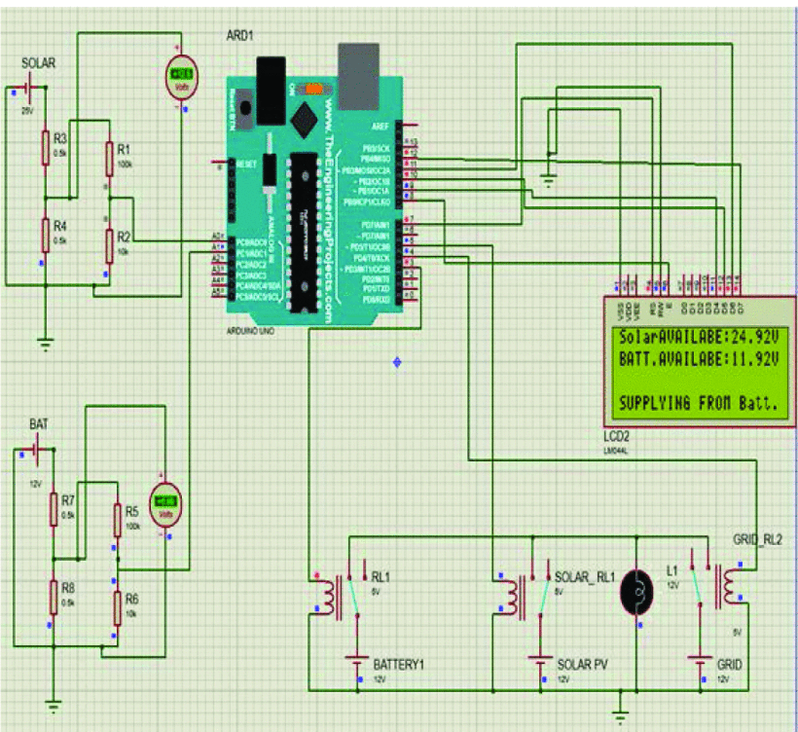

<https://ieeexplore.ieee.org/document/9313063>

<https://www.researchgate.net/publication/339980331_Design_and_Implementation_of_Automated_Switching_and_Real-Time_Monitoring_of_Hybrid_Solar_System>

<https://www.researchgate.net/publication/331437202_Solar_-_Grid_Hybrid_System_-_A_Cost_Effective_and_Improved_Renewable_Energy_Utilization_Approach>

<https://www.clearbluetechnologies.com/en/products/solar-controller>

<https://ieeexplore.ieee.org/document/6835155>

<https://ieeexplore.ieee.org/document/7387151>

<https://ieeexplore.ieee.org/stamp/stamp.jsp?tp=&arnumber=8685933>

<https://www.mouser.com/ProductDetail/STMicroelectronics/STM32L496RGT6P?qs=W0yvOO0ixfEnOJDcWnU8iA%3D%3D>

regulator : AMS1117

USB to serial: FT230X

<https://www.reddit.com/r/embedded/comments/lb05oo/if_i_buy_a_brand_new_stm32_microcontroller_do_i/>

<https://predictabledesigns.com/tutorial-how-to-design-your-own-custom-microcontroller-board-video-part1/>

<https://wiki.st.com/stm32mcu/wiki/STM32StepByStep:Step2_Blink_LED#cite_note-1>

<https://daniellethurow.com/blog/2021/6/16/getting-started-with-stm32-black-pill-getting-blinky-with-stm32cube-ide>

<https://legacy.cs.indiana.edu/~geobrown/book.pdf>

<https://www.printedcircuits.com/what-is-a-pcb/>

<https://electronics.stackexchange.com/questions/42840/how-to-go-from-a-development-board-to-a-production-board>

<https://www.mouser.com/STMicroelectronics/Semiconductors/Embedded-Processors-Controllers/Microcontrollers-MCU/ARM-Microcontrollers-MCU/STM32-Series/_/N-a85pcZgjdhub?P=1z0zpefZ1yz8wfe>

Current sense resistor

4080 or 4081

Crystal osci

Power ground

Advice:

https://www.mouser.com/datasheet/2/389/dm00613881-1799439.pdf

TLV70233

Data sheet:

<https://www.mouser.com/datasheet/2/389/dm00532745-1799456.pdf>

Need to measure three inputs: 2 from ADC, 1 from I2C using an external ADC.

Can I measure one voltage with one ADC?